**GIT ASSIGNMENT**

1. 1.Create a directory ‘project_dir’ & cd to ‘project_dir’.

2.Initialize git version database. (git init)

3.Create a new file index.html

4.Check the git status. You should find index.html as untracked file.

5.Stage the index.html file.

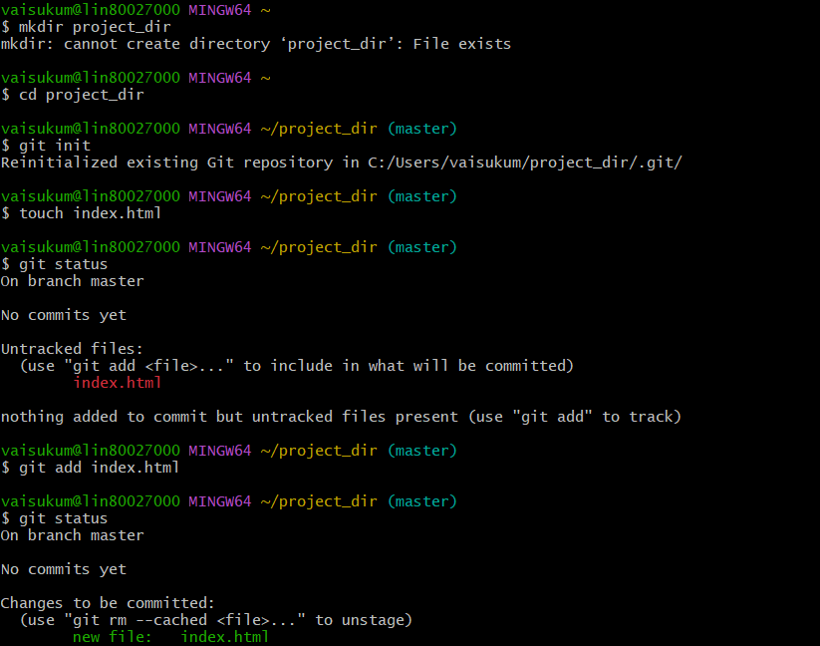

6.Commit index.html

7. Make few changes in index html and create a new file info.txt file

8.Check git status. You should find index.html and new file info.txt file as untracked.

9. Configure GIT to ignore all txt files.

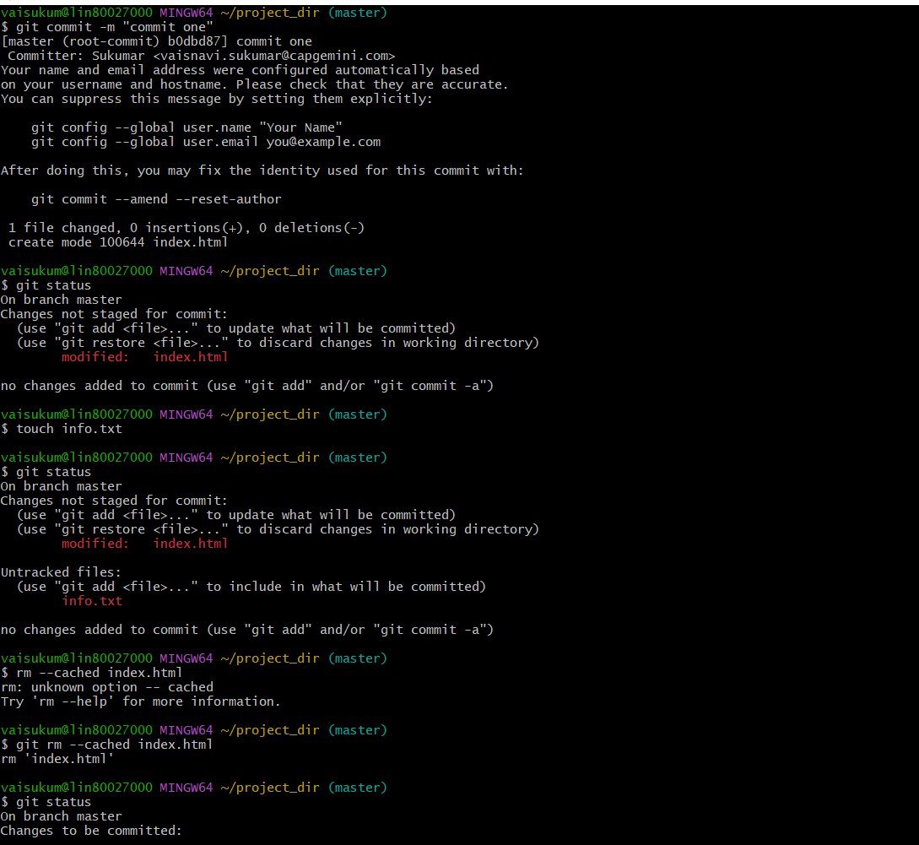

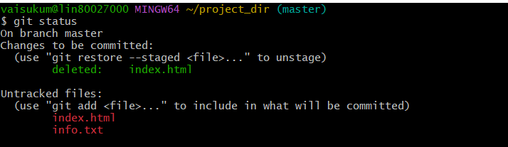

10.Again check the git status. You should find index.html & info.txt file.

11.State&commit index.html

12.Log all your comments so far.

13.Make some changes in index.html.

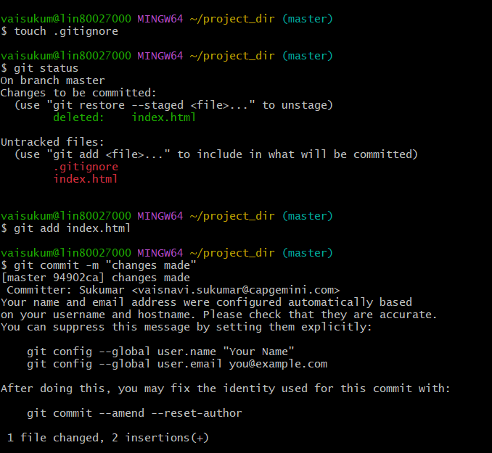

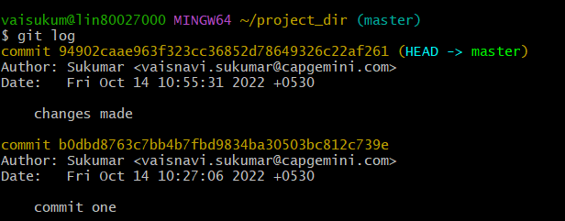

14.Revert the change made in the previous step using git command.

15.Again change index.html

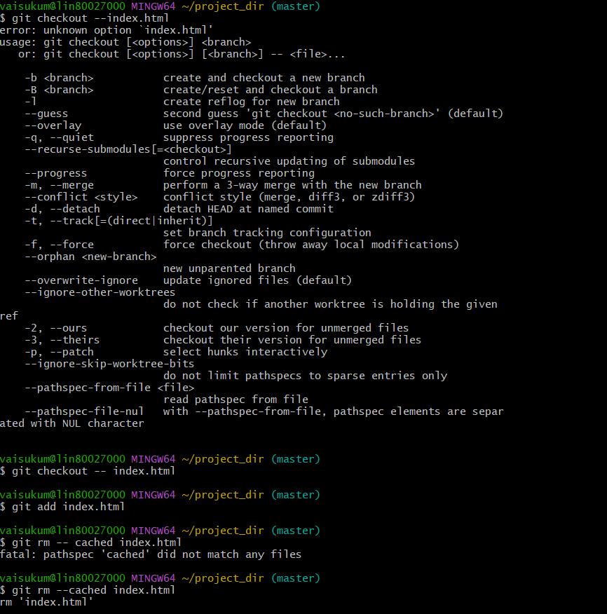

16. Stages index.html

17.Revert back the last stage

18.Rename 'add' command to 'my-add'.

19. Using my_add command to 'my-add".

20.Revert the last commit.

